**TIENG ANH 8 ( WEEK : 1 –6/2/2021)**

**Period 1 : Unit 10 Write: How to write instructions**

**New words**

**soak (v) nhúng**

**place = put**

**mix (v) trộn 🡪 mixture (n)**

1. **Complete the recycling instructions. Use the verbs in the box.**

soak              place            wrap                 dry

use               wait              mix                press

First, (0) **soak** some old newspapers in a bucket of water overnight. Then (1)_______ a wooden spoon to mash the paper. Next, (2)_____________ the mashed paper and the water together in another bucket. (3)__________ a wire mesh in the mixture then pull il out. Then put the mesh with mixture on the cloth and (4) __________ it down firmly. Take the mesh off the cloth. (5) __________ some heavy books in a plastic bag and out them on the cloth. (6)_______ about 5 minutes. Finally, put the books away and take the paper out of the cloth to (7)________ in the sunlight.

Giải

First, (0) soak some old newspaper in a bucket of water overnight. Then (1) **use** a wooden spoon to mash the paper. Next, (2) **mix** the mashed paper and the water paper together in another bucket. (3) **Place** a wire mesh in the mixture then pull it out. Then put the mesh with mixture on the cloth and (4) **press** it down firmly. Take the mesh off the cloth. (5) **Wrap** some heavy books in a plastic bag and put them on the cloth. (6) **Wait** about 5 minutes. Finally, put the books away and take the paper out of the cloth to (7) **dry** in the sunlight.

1. **In some areas people burn dry tea leaves to keep mosquitoes away. Look at the pictures. Make the instructions on how to prepare the tea leaves, using the given words in the box.**

**Giải**

a. First, **take** the used tealeaves from the teapot.

b. Next, **scatter** the tealeaves on a tray.

c. Then, **dry** the leaves in the sun.

d. Finally, **put** the dry leaves in a pot for future use.

### Period 2 and 3 : LANGUAGE FOCUS 1. Work with partner. (Hãy làm việc với bạn học.) How to recycle glass

Giải:

* a. The glass is broken into small pieces.
* b. Then the glass is washed with a detergent liquid.
* c. The glass pieces are completely dried
* d. The glass pieces are mixed with certain specific chemicals.
* e. The mixture is melted until it becomes a liquid.
* f. A long pipe is used. The mixture is dipped into the liquid. Then the liquid is blown into intended shapes.

**Trật tự tranh:** 1-4-3-5-2-6

### 2. A famous inventor. Dr. Kim, is going to build a time machine. One of his assistants. hai. is asking him questions about the invention. Complete the dialogue. Use the correct form of the verbs in brackets. Giải:

* Hai: When (0)**will the project be started**, Doctor? (Dự án sẽ được bắt đầu khi nào, Bác sĩ?)
* Dr. Kim: Very soon. (Rất sớm.)
* Hai: Many people want to see the time machine. (Nhiều người muốn xem cỗ máy thời gian.)
* Dr. Kim: Yes. It (1)**will be shown** to the public when it is finished. (Vâng. Nó sẽ sớm được trưng bày cho công chúng khi nó được hoàn thành.)
* Hai: (2) **Will it be built** by the end of the year. Doctor? (Nó sẽ được xây dựng vào cuối năm hả bác sĩ?)
* Dr. Kim: I'm afraid not, but it (3) **will be finished** before Tet. (Tôi e là không, nhưng nó sẽ được hoàn thành trước Tết.)
* Hai: (4) **Will it be made** by you? (Nó sẽ được làm bởi ông hả?)
* Dr. Kim: No. I need you to build it. When can you start? (Không. Tôi cần anh dựng nó. Khi nào anh có thể bắt đầu?)
* Hai: Let's begin tomorrow. (Chúng ta sẽ bắt đầu vào ngày mai nhé)

### Complete the dialogues. Use the words in the box. (Hoàn thành các đoạn hội thoại. Sử dụng các từ trong khung.)

### Form: It’s adjective + to verb

* It’s (0) difficult to follow your directions. )

b)

* It's (1)**easy to understand.**

c)

It’s (2) **hard to believe**.

d)

* It’s (3) **dangerous to go near the stove**. e)
* It’s (4) **important to wait for five minutes.**

**4. Complete the letter. Use the correct forms of the verb be and the adjectives in the box.** .)

**Note:**

**S+ be ( not) adjective that + noun clause ( S + V)**

**Look forward to Ving ( Ex: We look forward to having a picnic.)**

Giải:

Dear Nam,

Your grandfather and I (0) **are delighted** that you passed your English exam. Congratulations!

Aunt Mai (1) **was happy** that you remembered her birthday last week. She told me you gave her a beautiful scarf.

I (2) am relieved that your mother is feeling better. Please give her my love. We're looking forward to seeing you in June. However, grandfather (3) is afraid that the dav is wrong. (4) **Are you sure** that you're arriving on Saturday 20th? I (5) **am certain**that there are no trains from Ha Noi on Saturday.

Write soon and confirm your arrival date and time.

**Period 2: Unit 10 : B4; B5**

**4. Ask and answer questions with a partner.**

**Use the words to help you.**

*(Hỏi và đáp với bạn cùng học. Dùng từ để giúp em)*

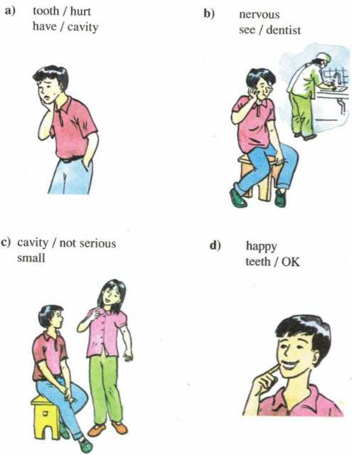

**Hướng dẫn**

a) Minh's tooth hurts.

Why?

Because he has a cavity.

b) He looks nervous?

Why?

Because he is seeing a dentist.

c) The cavity isn't serious.

Why?

Because it’s very small.

d) Minh looks happy.

Why?

Because his teeth are ok now.

**B5.**

**5. Write. Complete this poster with a partner.**

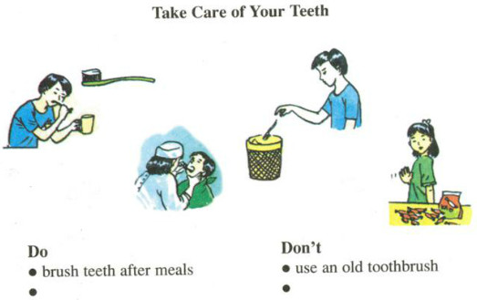

|  |  |
| --- | --- |
| **Take care of your teeth** | |
| **Do** | **Don’t** |
| - Brush teeth after meals  - Use a good toothbrush  - Use good toothpaste  - Go to a dentist when having a toothache | - Use an old toothbrush  - Eat lots of candy and sweets |

**Period 3 : Unit 11 A1**

**A. A check-up** (Phần 1-3 trang 107-109 SGK Tiếng Anh 7)

**1. Listen. Then practice with a partner.**

**New words :**

**have a medical check up (v)**

**fill in the medical record(v)**

**take someone’s temperature (v) đo nhiệt độ**

**degree Celsius ( độ c)**

**normal (a)**

**measure (v)**

**high (a) 🡪 height (n)**

**get on the scale (v)**

**weigh(v) 🡪 weight(n)**